# Investment Portfolio Summary

Embarking on this fascinating journey of stock trading simulation, this project report meticulously outlines the intricacies of our investment experience, encapsulating the strategies employed, decision-making processes, and the overarching dynamics that shaped the portfolio's performance throughout the designated period. Anchored by the investment profile and objectives meticulously crafted at the project's inception, this analysis serves as a reflective mirror, showcasing the alignment or deviation of outcomes with initial aspirations.

**Authors:** Yan Ge & Lebo Sango

**Program**: MSc. Applied Financial Economics

**Course**: Equity Securities and Markets - FIN 6160

**Supervisor**: Dr. Liuqing Mai

# Strategy

The cornerstone of a portfolio is the strategy determining the aim, style, and risk exposure of investment. In this section, we will discuss our general investment strategy, which highlights the portfolio general goals and comprehensive style; the constructing strategy, which narrows selections of securities; and the management strategy, which controls the portfolio’s risk exposure.

The portfolio short-term strategy observes two mandates. First, it aims at outperforming market consensus. Second, it seeks to minimize risk exposure. A positive market outlook marked the start of 2024, with market consensus averaging single-digit positive performance. The beginning of 2023 was mined with systematic risk embodying inflation, looming interest rate environment, and fear of recession. That said, the identification of sectors which tend to outperform while navigating these risks is the basis of this report. Leveraging financial platforms and measurements provided a clear optic of which investment strategy ought to be executed.

## Investment strategy

2024 is only the continuation of macroeconomic developments affecting financial markets and creating post-pandemic systematic uncertainty. Different relevant episodes are worth mentioning as global financial markets are still navigating them, such as the Covid-19 pandemic, the US government fiscal spending package to support the national economy in 2021 and 2022 which created a large flux of money in circulation, supply chain bottlenecks, reopening of global economies, global inflation, ballooning of asset prices in the housing markets, drastic rises of interest rates by the Federal Reserve to tame inflation down and bring the US economy back to feasible unemployment level, and bank failures. The goal of the strategy is to identify companies that formerly maneuvered these macroeconomic factors successfully and design the strategies below.

* First, the short-term investment horizon of the project extends from February 5th to April 8th. Thus, the portfolio is more focused on short-term speculative opportunities rather than value investments in the medium to long term. The decision-making framework is executed based on economic and market-related news.
* Second, due to the limitation of knowledge, derivatives and cryptocurrencies are excluded from our potential investment subjects.
* Third, to control risk exposure, our capital allocation strategy focused on investing in securities with high transaction volume.
* Fourth, to control unpredictive loss, the long position is the main trading strategy, supplemented by a few short positions.
* Finally, all investment operations should follow macroeconomic policies and events.

## Construction strategy

Obviously, macroeconomic forces are not to be disregarded for portfolio security selections. Thus, we ought to be cognizant of the importance of macroeconomic policies and circumstances that can significantly affect financial markets. Among the macroeconomic indices, inflation, interest rate, and unemployment levels are seen as the crucial elements. The year-over-year inflation reading is expected to hit the Fed’s 2 percent target in Q3 2024, and the expectation will lead to rate cuts starting in Q2 2024 (Erik L., p. 2). Inflation has shown a downward trend since 2022 reaching a 9 percent peak. Consumers were directly affected. The Federal Reserve led by Chair Jerome Powell aggressively increased rates to avoid price stickiness which could hinder US consumers. Between 2022 and 2023, The Federal Reserve Bank raised rates 11 times or 525 basis points to cool down prices. At the start of 2024, the Federal rate level is at 5.33% (Federal Reserve Bank of New York). Despite the rate increases, the U.S. economy showed resilience with sustained GDP growth while navigating market uncertainties. In 2023, both the Nasdaq 100 and S&P 500 had an excellent performance with 53.8% per Nasdaq Inc. and 24% as reported by Wall Street Journal. Since the start of 2024, the Nasdaq100 rallied 7.4% and 5.35% per Google Finance. According to the Bureau of Economic Analysis, US real GDP increased at an annual rate of 3.3% by the end of Q4 2023 (2024). The growth of the US economy was reflected despite Economic challenges by the confidence in consumer spending in services and goods (health care and recreational goods and vehicles), the increase in state and local government spending, in the export of both goods and services and the federal government spending in non-defense and defense contracts. However, some weaknesses of the economy are worth mentioning such as the decrease in residential investments, the personal saving rate falling by 0.2%, and the increase in credit delinquencies. An aggressive interest environment makes it difficult for businesses to conduct expansionary investment initiatives and forcing them to adopt conservative expenditure measures. Most companies went further by cutting headcounts to mitigate their expense ratios. The US Bureau of Labor Statistics (2024) reported that the national unemployment rate remained unchanged at 3.7 percent by the end of Q3 2023 but was up from 0.2% in 2022. Layoffs were mostly noticeable in the technology sector, more than 93,000 jobs were cut in 2022; 191,000 jobs in 2023, and so far in 2024, 12,402 US-based technology workers have lost their jobs, according to Crunchbase News daily. The leading workforce reduction companies are Amazon, Alphabet, Microsoft, and Meta. Some would argue that the cuts are justified due to excess hiring in 2020 and recently, the launch of Artificial Intelligence as some of these companies can still operate with a leaner workforce while automating their internal processes for faster solution deliveries to consumers and clients. Job cuts are a conservative measure applied when market environments become gloomy while waiting for any improvement of macroeconomic indicators.

Considering the above statement, we used top-down approach to construct the portfolio. According to the current economy, there are two narrowing rules. First, avoid investing in consumer-related industries based on fundamentals, while considering speculative investments based on technical analysis. The reasons are apparent. In fact, the Federal Reserve is likely to raise or maintain interest rate levels to reduce inflation. Second, investing in the financial sector is not attractive because interest rates represent a major cost in the banking sector. Additionally, we have chosen two sectors as our portfolio's main investment themes.

First, the healthcare sector often emerges as a bastion of stability during economic downturns, offering a defensive investment strategy that contrasts sharply with the broader market's volatility. In 2023, specific entities within this domain not only defied general market expectations but also significantly outperformed major indices such as the S&P 500 and the technology centric Nasdaq100. This remarkable growth has piqued investor interest in understanding the underlying dynamics propelling these companies forward. Prominently, Eli Lilly and Company (LLY), Intuitive Surgical Inc (ISRG), and West Pharmaceutical Services Inc (WST) distinguished themselves as the sector's leading performers, boasting annual returns of 89.1%, 56.14%, and 42.48%, respectively, as reported by Nerd Wallet. Despite the healthcare industry's resilience, it is not impervious to both systemic and idiosyncratic risks. The latter category, in particular, hinges on factors such as regulatory landscapes, the outcomes of drug trials across various stages, and approvals by relevant health authorities for the commercial production and distribution of novel treatments. These elements can precipitate fluctuations in a company's market valuation, leading to potential gains or losses. For instance, Eli Lilly recently made headlines due to negotiations with the German government concerning reimbursement for its Monjaro weight loss medication aimed at treating obesity, despite Germany's lack of a specific reimbursement framework for such treatments, potentially affecting the company's stock valuation negatively. Conversely, positive developments can significantly enhance a company's market value. An illustrative case involves the Canadian government's approval of Olumiant for treating severe alopecia areata, as evidenced by the Notice of Compliance (NOC) issued by Health Canada. This approval, which focuses on restoring eyebrow and eyelash growth, is anticipated to elevate Eli Lilly's valuation to unprecedented levels.

Second, reflecting on the dot-com bubble era, a period marked by both enthusiasm and trepidation, it is noteworthy that companies eagerly suffixed their names with “.com” to signal their alignment with burgeoning internet technologies. This speculative frenzy, however, was short-lived, culminating in a burst during the early 2000s. Despite this, the episode paved the way for significant technological advancements. Notably, entities that adeptly harnessed internet capabilities witnessed exponential stock growth exceeding 1000% over the subsequent two decades, with firms like Microsoft, Apple, and Alphabet standing as quintessential examples. Furthermore, the domain of artificial intelligence (AI), once broadly perceived as an open secret (a secret of Polichinelle), has undergone transformative developments, particularly in its application to enhance business scalability, thereby optimizing productivity and profitability while reducing inefficiencies. It is projected that entities proficient in integrating AI into their operational frameworks will sustain competitive advantages in the coming decades. The AI era is distinguished by swift technological evolutions, especially in machine learning, deep learning, and extensive language models. These advancements have been propelled by algorithmic refinements, the proliferation of vast datasets, and enhanced computational capacities, leading to significant strides in natural language processing, computer vision, and other AI-centric fields. In the context of AI hardware, a selective analysis reveals four companies poised at the forefront of the AI revolution. Our analysis highlights three companies that have reported over 50% stock performance improvement since the onset of 2024 to February 2024, cumulatively amassing a market capitalization of $2.6224 trillion, which equates to approximately $8,100 per capita in the United States, according to data from Google Finance, with NVIDIA constituting a significant portion of this valuation. Given these dynamics, the advent of AI computing heralds a new epoch, necessitating preparedness and strategic foresight.

## Management strategy

In managing a diverse investment portfolio, it's crucial to employ a strategic blend of technical analysis tools and risk management techniques to navigate market volatilities effectively. Two pivotal technical indicators in our strategy are the Moving Average Convergence Divergence (MACD) and Bollinger Bands. The MACD is instrumental in identifying momentum shifts and potential trend reversals by evaluating the relationship between two moving averages of a security's price. Bollinger Bands, on the other hand, provide insights into price volatility and overbought or oversold conditions by plotting standard deviation levels around a moving average.

To mitigate risk and safeguard our investments, setting precise stop-loss and stop-gain targets is fundamental. Stop-loss orders are strategically placed to limit potential losses by automatically selling a security when its price falls to a specified level. Conversely, take-profit orders are set to capitalize on gains by selling a security when its price reaches a predetermined peak, ensuring we lock in profits before any potential downturn.

An additional layer of our strategy involves cautious position management around the release of significant economic indicators such as the Consumer Price Index (CPI), Personal Consumption Expenditures (PCE), and unemployment rates. The volatility spurred by these announcements can lead to unpredictable market movements. Therefore, we aim to minimize exposure by avoiding the augmentation of positions shortly before these critical data are released. This approach not only prevents unnecessary losses but also positions our portfolio to capitalize on post-announcement market adjustments with greater clarity and reduced risk. Through the judicious application of these strategies, we strive to achieve a balanced and resilient investment portfolio capable of navigating the complexities of the financial markets.

# Security Descriptions

## Eli Lilly & Co – LLY

* **Sector**: Healthcare
* **Industry**: Pharmaceuticals
* **Headquarters**: Lilly Corporate Ctr, INDIANAPOLIS, IN 46285-00
* Founded in 1876, Eli Lilly & Co. is engaged in the drug manufacturing business. The company discovers, develops, manufactures and markets products in the human pharmaceutical products segments. Its diabetes, obesity and other cardiometabolic products include Basaglar, Humalog, Humlin, Jardiance, Mounjaro, Trulicity, and Zepbound. Its oncology products include Alimta, Cyramza, Erbitux, Jaypirca, Retevmo, Tyvyt and Verzenio. Its immunology products include Ebglyss, Olumiant, Omvoh and Taltz. Its neuroscience products include Cymbalta and Emgality. Its other products and therapies include Cialis and Forteo. The Company manufactures and distributes its products through facilities in the United States (U.S.), including Puerto Rico, and in Europe and Asia. The Company, through its subsidiary, POINT Biopharma Global Inc., is engaged in radiopharmaceutical discovery, development, and manufacturing, as well as clinical and pre-clinical radioligand therapies in development for cancer treatment.

**LLY Fundamentals**

|  |  |  |  |  |  |  |
| --- | --- | --- | --- | --- | --- | --- |
| EPS[1] | PE[2] | ROE[3] | GM[4] | D\E[5] | Beta | Stock Performance |
| 5.8 | 133.58x | 48.93% | 79.25% | 2.34x | 0.9 | 31% |

## NVIDIA CORPORATION COM - NVIDA

* **Sector**: Technology.
* **Industry**: Semiconductors and Semiconductors Equipment.
* **Headquarters**: 2788 San Tomas Expressway SANTA CLARA, CA 95051.
* NVIDIA Corporation is a full-stack computing infrastructure company. The Company accelerates computing to help solve computational problems. The Company’s segments include Compute & Networking and Graphics. Compute & Networking segment includes its data center accelerated computing platform; networking; automotive artificial intelligence (AI), cockpit, autonomous driving development agreements and autonomous vehicle solutions; electric vehicle computing platforms; NVIDIA AI Enterprise and other software. The Graphics segment includes GeForce GPUs for gaming and personal computers (PCs), the GeForce NOW game streaming service and related infrastructure, and solutions for gaming platforms; Quadro/NVIDIA RTX GPUs for enterprise workstation graphics; virtual GPU (vGPU), software for cloud-based visual and virtual computing; automotive platforms for infotainment systems; and omniverse enterprise software for building and operating metaverse and three-dimensional Internet applications.

**NVDA Fundamentals**

|  |  |  |  |  |  |  |
| --- | --- | --- | --- | --- | --- | --- |
| EPS[6] | PE[7] | ROE[8] | GM[9] | D\E[10] | Beta | Stock Performance |
| 5.8 | 77.6x | 91.46% | 72.72% | 0.23x | 2.3 | 83% |

## ARM HOLDINGS PLC SPONSORED ADR - ARM

* **Sector**: Technology.
* **Industry**: Semiconductors and Semiconductor Equipment.
* **Headquarters**: 110 Fulbourn Road Cambridge, CB1 9NJ
* Arm Holdings plc is a semiconductor intellectual property (IP) company. The Company develops and licenses IP for various devices worldwide, and it provides development tools that accelerate product development, from sensors to smartphones to servers. Its central processing unit (CPUs) and nomenclature for properties and units (NPUs) include Cortex-A, Cortex-M, Cortex-R, Neoverse, Ethos and SecurCore. It provides processor IP, offering a range of cores to address the performance, power and cost requirements of every device, from Internet of things sensors to supercomputers, and from smartphones and laptops to autonomous vehicles. Its graphics and camera technology drives the visual experience across a range of devices, including mass-market to high-performance smartphones, Android OS-based tablets, and digital televisions. It provides foundation physical IP and processor implementation solutions to address the performance, power and cost requirements for all application markets.

**ARM Fundamentals**

|  |  |  |  |  |  |  |
| --- | --- | --- | --- | --- | --- | --- |
| EPS[11] | PE[12] | ROE[13] | GM[14] | D\E[15] | Beta | Stock Performance |
| 0.08 | 622.18x | 0.0% | 0.00% | 0.0x | 2.7 | 72% |

## SUPER MICRO COMPUTER INC COM - SMCI

* **Sector**: Technology.
* **Industry**: Computers, Phones & Household Electronics.
* **Headquarters**: 980 Rock Ave San Jose, CA 95131-1615 .
* Super Micro Computer, Inc. is an application-optimized Total IT solution. The Company provides Silicon Valley-based provider of accelerated compute platforms that are application-optimized server and storage systems for a variety of markets, including enterprise data centers, cloud computing, artificial intelligence (AI), fifth generation (5G) and edge computing. Its Total IT Solutions includes complete servers, storage systems, modular blade servers, blades, workstations, full rack scale solutions, networking devices, server sub-systems, server management and security software. It also provides global support and services to help its customers install, upgrade and maintain their computing infrastructure. Its products include servers & storage, building blocks, IoT & embedded, networking, and workstations & gaming products. IoT & Embedded products include Embedded SuperServers, Embedded Motherboards, Embedded Chassis and Global SKUs. It operates in the United States, Asia and Europe.

**SMCI Fundamentals**

|  |  |  |  |  |  |  |
| --- | --- | --- | --- | --- | --- | --- |
| EPS[16] | PE[17] | ROE[18] | GM[19] | D\E[20] | Beta | Stock Performance |
| 12.8 | 80.12x | 29.92% | 16.39% | 0.12x | 4.0 | 261% |

## PALANTIR TECHNOLOGIES INC CL A - PLTR

* **Sector**: Technology
* **Industry:** Software and IT services
* Headquarters: 1200 17Th Street, Floor 15 Denver, CO 80202
* Palantir Technologies Inc. is engaged in building software to assist in counterterrorism investigations and operations. It has built four principal software platforms, including Palantir Gotham (Gotham), Palantir Foundry (Foundry), Palantir Apollo (Apollo), and Palantir Artificial Intelligence Platform (AIP). Apollo is a cloud-agnostic, single control layer that coordinates ongoing delivery of new features, security updates, and platform configurations, helping to ensure the continuous operation of critical systems. Gotham enables users to identify patterns hidden deep within datasets, ranging from signals intelligence sources to reports from confidential informants. Foundry transforms the ways organizations operate by creating a central operating system for their data. AIP enables responsible artificial intelligence (AI)-advantage across the enterprise by using primary, core components built to effectively activate large language models (LLMs) and other AI within any organization.

**PLTR Fundamentals**

|  |  |  |  |  |  |  |
| --- | --- | --- | --- | --- | --- | --- |
| EPS[21] | PE[22] | ROE[23] | GM[24] | D\E | Beta | Stock Performance |
| 12.8 | 275.15x | 29.92% | 80.62% | 0.0x | 3.2 | 36% |

## RTX CORPORATION COM - RTX

* **Sector**: Industrials
* **Industry**: Aerospace and Defense.
* **Headquarters**: 1000 Wilson Blvd Arlington, VA 22209
* RTX Corporation is an aerospace and defense company, which provides advanced systems and services for commercial, military, and government customers worldwide. The Company operates through three segments: Collins Aerospace, Pratt & Whitney, and Raytheon. Collins Aerospace segment provides technologically advanced aerospace and defense products and aftermarket service solutions for civil and military aircraft manufacturers, commercial airlines, and regional, business and general aviation, as well as for defense and commercial space operations. The Pratt & Whitney segment supplies aircraft engines for commercial, military, business jet, and general aviation customers. The Raytheon segment provides defensive and offensive threat detection, tracking and mitigation capabilities for the United States and foreign government and commercial customers. Raytheon designs, develops, and provides advanced capabilities in integrated air and missile defense, smart weapons, missiles and others.

**RTX Fundamentals**

|  |  |  |  |  |  |  |
| --- | --- | --- | --- | --- | --- | --- |
| EPS[25] | PE[26] | ROE[27] | GM[28] | D\E[29] | Beta | Stock Performance |
| 2.3 | 42.65x | 4.83% | 17.54% | 0.73x | 0.2 | 16% |

## META PLATFORMS INC CL A - META

* **Sector**: Technology.
* **Industry**: Software & IT Services.
* **Headquarters**: 1 Meta Way Menlo Park, CA 94025
* Meta Platforms, Inc. builds technology that helps people connect and share, find communities, and grow businesses. The Company’s products enable people to connect and share with friends and family through mobile devices, personal computers, virtual reality (VR) and mixed reality (MR) headsets, and wearables. It operates through two segments: Family of Apps (FoA) and Reality Labs (RL). The FoA segment includes Facebook, Instagram, Messenger, Threads and WhatsApp. The RL includes augmented, mixed Threads is an application for text-based updates and public conversations. Its RL product offerings in VR include Meta Quest devices, and software and content available through the Meta Quest Store, which enables a range of social experiences.

**META Fundamentals**

|  |  |  |  |  |  |  |
| --- | --- | --- | --- | --- | --- | --- |
| EPS[30] | PE[31] | ROE[32] | GM[33] | D\E[34] | Beta | Stock Performance |
| 15.29 | 32.43x | 29% | 80.72% | 0.12x | 1.9 | 39% |

## LYFT INC CL A COM - LYFT

* **Sector**: Technology.
* **Industry**: Software & IT Services.
* **Headquarters**: 185 Berry Street, Suite 400 San Francisco, CA 94107
* Lyft, Inc. is a multimodal transportation network in the United States and Canada that offer access to a variety of transportation options through its platform and mobile-based applications. The Lyft Platform provides a marketplace where drivers can be matched with riders via the Lyft App, where it operates as a transportation network company. Transportation options through its platform and mobile-based applications are substantially comprised of its ridesharing marketplace that connects drivers and riders in cities across the United States and in select cities in Canada, its network of bikes and scooters, and the Express Drive program, where drivers can enter into short-term rental agreements with its subsidiary, Flexdrive Services, LLC or a third party for vehicles that may be used to provide ridesharing services on the Lyft Platform. It makes the ridesharing marketplace available to organizations through Lyft Business offerings, such as the Concierge and Lyft Pass programs.

**LYFT Fundamentals**

|  |  |  |  |  |  |  |
| --- | --- | --- | --- | --- | --- | --- |
| EPS[35] | PE[36] | ROE[37] | GM[38] | D\E[39] | Beta | Stock Performance |
| -0.899 | 00x | -73.17% | 32.53% | 1.79x | 3.1 | 31% |

# Transaction Details

For NVIDIA Corp., we have two holding periods.

|  |  |  |  |  |  |
| --- | --- | --- | --- | --- | --- |
| Symbol | Trans. Type | Quantity | Price | Amount | Trans. Date |
| NVDA | Limit - Sell | -300 | $739.01 | $221,703.00 | 2/12/24 - 11:03 |
| NVDA | Market - Buy | 100 | $712.00 | ($71,200.00) | 2/09/24 - 10:18 |
| NVDA | Limit - Buy | 200 | $687.81 | ($137,562.00) | 2/05/24 - 15:07 |

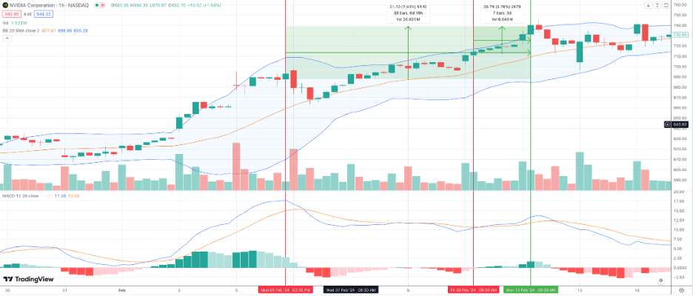

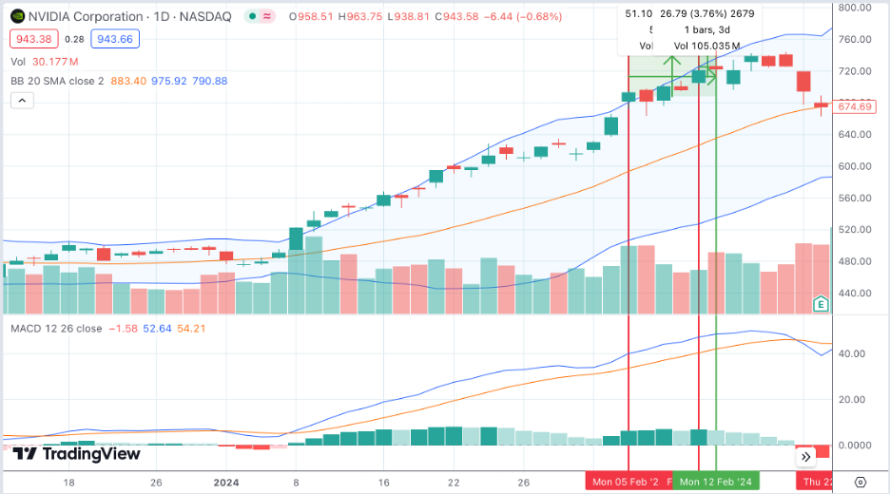

In the first holding period, we purchased NVIDIA on 5th Feb at $687.81 and on 9th Feb at $712.00, then we cleared NVIDIA position on 12th Feb at $739.01. Among 8 days, the holding period return (HPR) is 6.20% and the standard deviation is 14.65. From the perspective of technical analysis, the time to buy was not very good, the price position is above the Bollinger brand in the daily Kindle graph and above the average line of the Bollinger brand in the one-hour Kindle graph.

|  |  |  |  |  |  |
| --- | --- | --- | --- | --- | --- |
| Symbol | Trans. Type | Quantity | Price | Amount | CreateDate |
| NVDA | Limit - Sell | -900 | $945.01 | $850,509.00 | 3/22/24 - 13:10 |
| NVDA | Limit - Buy | 200 | $894.61 | ($178,922.00) | 3/12/24 - 13:13 |
| NVDA | Dividends | 700 | $0.04 | $28.00 | 3/05/24 - 00:00 |
| NVDA | Market - Buy | 700 | $759.65 | ($531,755.00) | 2/22/24 - 09:37 |

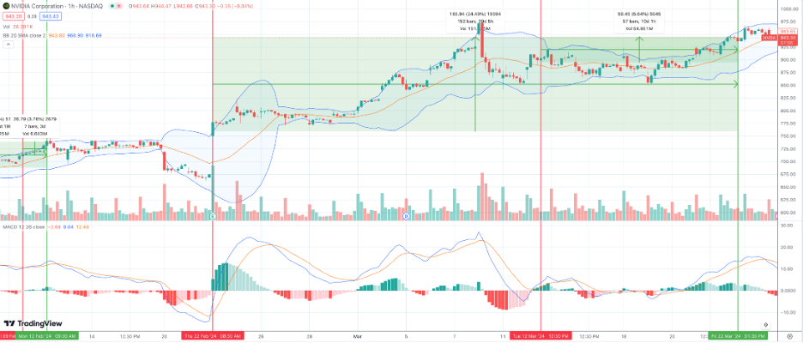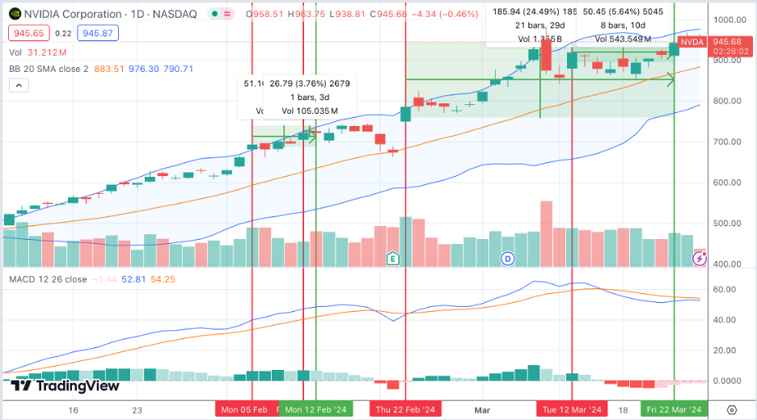

In the second holding period, we purchased NVIDIA on 22nd Feb at $759.65 and on 12th Mar at $894.61, then we cleared the NVIDIA position on 22nd Mar at $945.01. Besides, we also got $28 dividends on 5th Mar. Within one month, the holding period return (HPR) is 19.68% and the standard deviation is 52.01. From the perspective of technical analysis, the time to buy was feasible because NVIDIA has been very hot recently and its price was always near the upper boundary of the Bollinger brand, so our purchase position was at a relatively low position. Additionally, both of our purchases were at or near the intersection of the MACD averages. We tried to confirm the uptrend before placing a buy order and leaving the market when we thought there would be a downtrend. The results show that our strategy is very successful. In general, NVIDIA brought a 16.62% return to our portfolio.

For Super Micro Computer Inc.(SMCI), we have three holding periods.

|  |  |  |  |  |  |
| --- | --- | --- | --- | --- | --- |
| Symbol | Trans. Type | Quantity | Price | Amount | Trans. Date |
| SMCI | Limit - Sell | -400 | $800.20 | $320,080.00 | 2/12/24 - 11:02 |
| SMCI | Limit - Buy | 100 | $739.95 | ($73,995.00) | 2/9/24 - 10:32 |
| SMCI | Limit - Buy | 100 | $739.95 | ($73,995.00) | 2/9/24 - 10:32 |
| SMCI | Limit - Buy | 200 | $698.43 | ($139,686.00) | 2/8/24 - 14:38 |

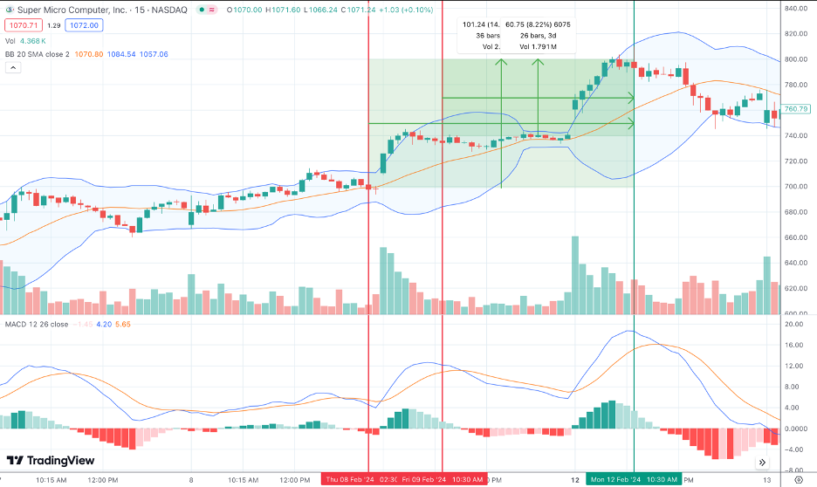

In the first holding period, we purchased SMCI on 8th Feb at $698.43 and on 9th Feb at $739.95, then we cleared SMCI position on 12th Feb at $800.20. For 3 days, the holding period return (HPR) is 11.26 % and the standard deviation is 30.71. From the perspective of technical analysis, the time to buy was good, the price position approached the average line of the Bollinger brand in the one-hour Kindle graph. Besides, MACD shows the time we purchased was decreasing.

|  |  |  |  |  |  |
| --- | --- | --- | --- | --- | --- |
| Symbol | Trans. Type | Quantity | Price | Amount | Trans. Date |
| SMCI | Market - Sell | -250 | $707.00 | $176,750.00 | 2/2/24 - 10:32 |
| SMCI | Limit - Buy | 250 | $963.51 | ($240,877.50) | 2/15/24 - 11:49 |

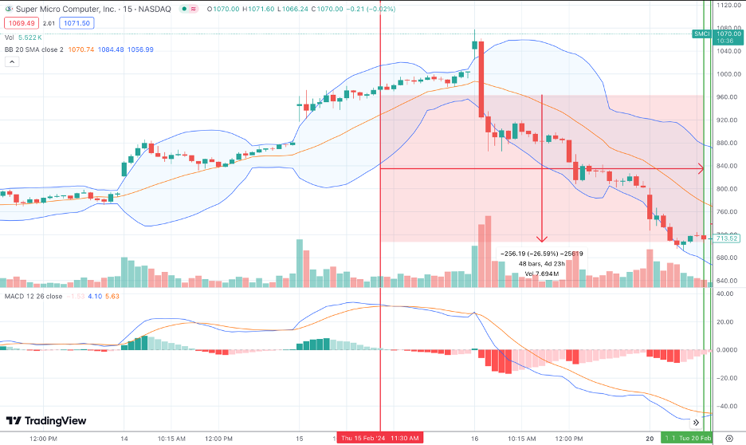

In the second holding period, we purchased SMCI on 15th Feb at $963.51, then we cleared SMCI position on 20th Feb at $707.00. Among the 3 days, the holding period return (HPR) is -26.62 % and the standard deviation is 98.52. From the perspective of technical analysis, the time to buy was not bad, since the price position is between the upper boundary and the average line of the Bollinger band in the one-hour Kindle graph. Moreover, MACD also showed a strong up power trend. However, the market met a strong depreciation after the U.S. Bureau of Labor published CPI.

|  |  |  |  |  |  |
| --- | --- | --- | --- | --- | --- |
| Symbol | Trans. Type | Quantity | Price | Amount | Trans. Date |
| SMCI | Short Proceeds | 600 | $775.00 | ($426,621.00) | 2/20/24 - 15:00 |
| SMCI | Stop - Cover | 600 | $775.00 | ($38,379.00) | 2/20/24 - 15:00 |
| SMCI | Short Proceeds | -300 | $719.29 | $215,787.00 | 2/20/24 - 11:15 |
| SMCI | Short Proceeds | -300 | $702.78 | $210,834.00 | 2/20/24 - 10:37 |

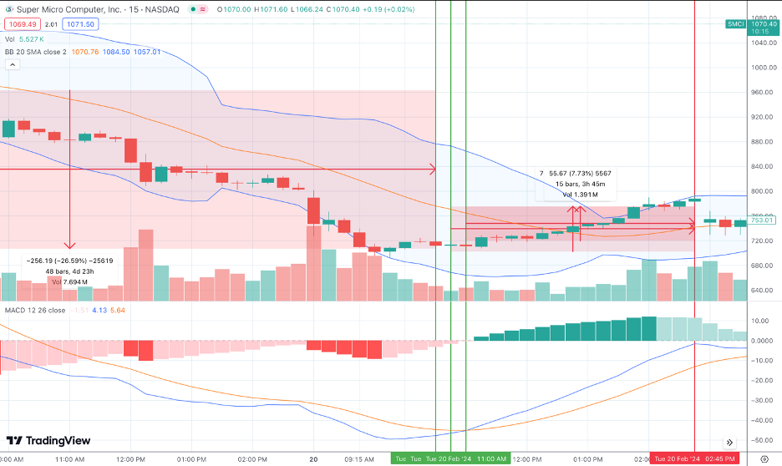

In the third holding period, we shorted SMCI on 20th Feb at $702.78 and $719.29, then we immediately cleared SMCI’s position on the same day at $775.00. Within 1 day, the holding period return (HPR) was -9.00 %. During the trade execution, we didn’t price in enough information, and haven’t had prior knowledge of shorting. Therefore, we veered into an emotional dilemma.

In general, the investment of SMCI brought a -7.34% return to our portfolio. Compared with other investments, NVIDIA gave the highest HPR to our portfolio and SMCI took the worst HPR. In summary, they both belong to AI sector companies, but our investment operation brings them completely different results. We conclude with several reasons:

* First, before any investment, we should collect enough information about our investment subjects. We took a lot of information about NVIDIA but not SMCI. So, we invested in NVIDIA with confidence, but not SMCI. This difference will easily make people get into emotional deals and ignore the initial investment strategy.
* Second, avoiding the emotional deals. An effective method to prevent investors from falling into emotional deals is to limit the time of observations to follow the market every day. In the later investment, we adopt this method and successfully prevent emotional deals.
* Third, set a looser stop-loss point than a stop-gain point. During this investment, we had strong confidence in the AI sector based on our investigation. Hence, we set a looser stop-gain point than a stop-loss point, but the truth is that stop-gain is more important than stop-loss. Otherwise, investors are easy to be affected by the market inflection.

We believe the roles of technical analysts, fundamental analysts, and trader analysts are best served by distinct individuals. Segregating the influx of information from varied channels ensures that each analyst remains unbiased in their investment advisory capacity. This separation is instrumental in maintaining objectivity and ensuring that recommendations are based on specialized and independent market analysis.

# Investment Performance Recapitulation

## Macroeconomic & Company Event Analysis

The success of our investment strategies relied on anticipating macroeconomic news. Indeed, the market follows the random-walk hypothesis which contradicts the market efficiency hypothesis. This confirms the uncertainty in the rational behavior of market movements. For instance, between the 6th, of February to the 9th of February, LLY topped the market consensus estimates from analysts for their fourth quarter. The day before the release of the month-over-month core CPI and CPI, the S&P 500 returns fell to –0.4% from 0.56% and on the day of, market return went even further down to –1.4%. The market retreated as it had anticipated a hotter-than-expected monthly inflation report. Then, the market rebounded partially, recovering its two-day recurrent loss. Moreover, the AI frenzy continued to rally until mid-March. No significant news revolving around companies restructuring within the space, buyouts, merging and acquisitions, or recent IPOs could rationalize massive fund inflows in this investment theme, yet sell-side investment analysts mostly raised or upgraded price targets of NVDA and SMCI, which created a FOMO event, in which current price levels of these companies did not reflect future prices. By the same token, current stock prices should be adjusted for future growth leading to massive volatility. The FOMO effect was le plat du jour, although NVDA momentum was also justified through its fiscal revenue outlook for 2024 projected to grow, and GTC conference, where they announced the release of a new chip that will further support AI performance on devices. Furthermore, market participants fastened their seatbelts as they were bracing for an interest rate hike impact. On March 20th Fed. Chair Jerome P. left the interest rate unchanged, and SPY enjoyed a 1.20% return for two days, then dropped three consecutive days later. Financial markets are not immune to systematic risks, however, through our diligence and vigilance to anticipate market volatility, we tended to clear our positions to realize the gains and setting trading techniques such as stop loss order or limit sell to mitigate risks. Nonetheless, some believe that some news might not be of relevance while navigating the defense and aerospace industry, we initially believed that investing in RTX would hedge against inflation and interest rate risks, yet as the war in Israel broke out, there had not been massive fund inflows into the stock to realize capital gains in our portfolio. As a conservative deduction, we concluded that the said space is supported by the central government and the industry growth space is tied to earning government defense contract, which can be a tedious process. In a nutshell, the investment strategy on recapitulating news aided in identifying trends in deciding whether we should enter the market, such as anticipating earning releases and paying attention to economic data releases.

## Performance Analysis

To analyze our portfolio performance, we chose SPY as the benchmark. The curve chart below shows the daily return curve for both SPY and our portfolio.

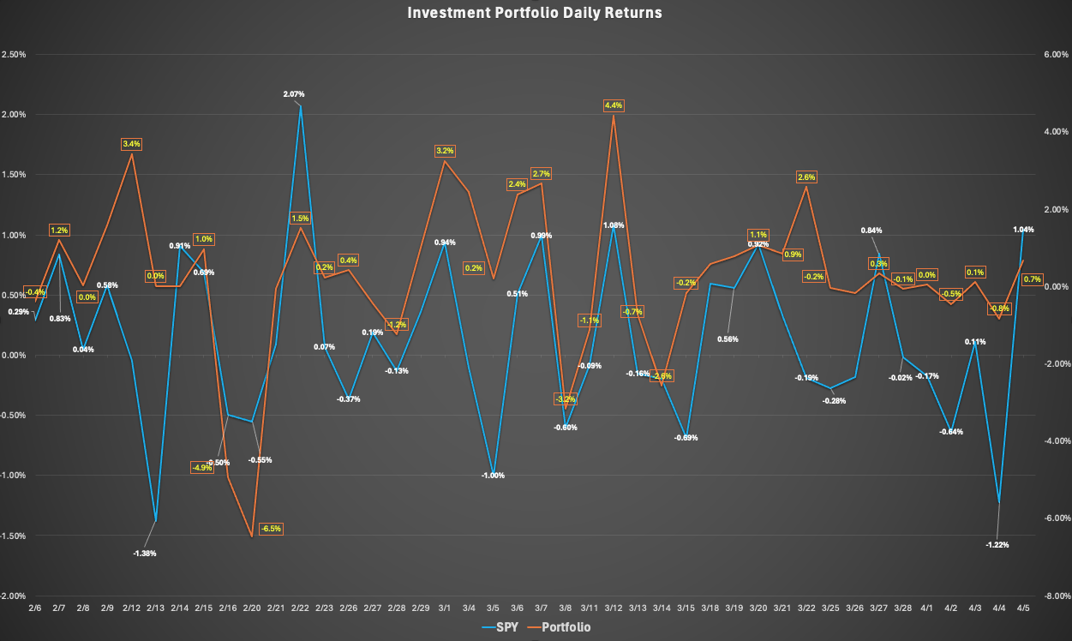

According to the above figure, it is obvious that our portfolio has a much higher variance than SPY, and in final our return doesn’t perform better too much than SPY. To get more details, we further calculate several indicators to analyze our portfolio.

|  |  |  |
| --- | --- | --- |
|  | SPY | Portfolio |
| Net return | 5.58% | 9.53% |
| Daily return | 0.13% | 0.22% |
| APR | 60.32% | 119.95% |
| STD. deviation | 0.68% | 1.98% |
| Sharp ratio | 17.34% | 10.36% |
| Covariance | 0.0067% | |

As speculation based on the daily return curve, our portfolio has more than double the risk of SPY. Our portfolio has a net return of 0.29%, which is higher than SPY's net return of 0.18%. This suggests that, in the short term, the portfolio has outperformed SPY in terms of raw returns. Besides, the Annual Percentage Rate (APR) further accentuates this point, with the portfolio boasting an APR of 184.85% compared to SPY's 93.45%. This significant difference highlights the aggressive growth strategy of your portfolio, delivering substantial returns over the analyzed period . The standard deviation for the portfolio is 1.98%, substantially higher than SPY's 0.68%. This confirms the speculation that the portfolio carries more than double the risk compared to SPY, indicating a much higher volatility and, consequently, a higher risk of investment. The Sharpe ratio of our portfolio is 13.95%, which is significantly lower than SPY's 24.92%. Despite the portfolio's higher returns, its Sharpe ratio suggests that these returns do not adequately compensate for the added risk, especially when compared to SPY. This ratio is crucial as it considers both the return and the risk, revealing that SPY provides a better risk-adjusted return. Furthermore, we calculate the daily free-risk rate based on the 10-year US Treasury and use SPY as the benchmark of the market to get the below indicators:

|  |  |
| --- | --- |
| Risk-free rate | 4.24% |
| Daily risk-free rate | 0.01% |
| Beta | 2.9059 |
| Alpha | -5.2975% |

For the beta coefficient, with a beta of 1.4529, the portfolio is significantly more volatile than the market (SPY). A beta greater than 1 indicates that the portfolio is more sensitive to market movements, which corresponds with the higher standard deviation observed. This heightened volatility implies that in bear markets, our portfolio could underperform significantly compared to SPY. Additionally, the alpha of the portfolio is 0.031%, which, although positive, indicates only a slight ability to generate excess returns over the benchmark (SPY) after adjusting for risk. A positive alpha is desirable as it suggests outperformance on a risk-adjusted basis, but the small magnitude here signals that the excess returns are minimal when the higher risk is considered.

Moreover, we also assume our portfolio is a passive investment to compare the performance, but we omit dividend income for the passive investment. We use Markowitz’s optimal boundary model to assign each stock’s weight.

|  |  |  |  |
| --- | --- | --- | --- |
|  | **SPY** | **Portfolio** | **Passive Investment** |
| **Net return** | 5.58% | 9.53% | 10.31% |
| **Average daily return** | 0.13% | 0.22% | 0.23% |
| **APR** | 60.32% | 119.95% | 134.61% |
| **Std. Deviation for Market** | 0.68% | 1.98% | 0.57% |
| **Sharp ratio** | 17.34% | 10.36% | 41.13% |
| **Beta** |  | 2.9059 | 0.8357 |
| **Alpha** |  | -5.2975% | 0.1176% |

Based on the above table, we know that our portfolio faced more risks but gained less than the passive investment strategy. Simultaneously, we spent more on transaction fees. The curve chart below shows the daily return curve for SPY, our portfolio, and passive investment.

In total, we executed 61 trades over 2 months. Thus, the sum of the transaction costs was $610 and comprised 0.64% of the portfolio net income. After this portfolio management, we realized that we should also set a goal to limit our transaction times. It is helpful to avoid emotional deals.

# Summary

The report provides a comprehensive examination of the stock trading simulation, including the formulation of investment strategies, the decision-making processes, and the analysis of the portfolio's performance over 2 months. A foundational investment profile and objectives were delineated at the inception, and the report reflects on the adherence to or divergence from these initial goals. The investment strategy revolved around outperforming the market consensus with minimized risk exposure. This was pursued amid a positive market outlook at the start of 2024, despite the prevailing systematic risks such as inflation and the anticipation of a recession. Sector selection was critical, and the strategy hinged on leveraging financial tools to execute informed investments. In particular, the report details the strategy's navigation through the macroeconomic landscape of 2024, which was filled with challenges from the lingering effects of the COVID-19 pandemic to inflationary pressures and bank failures. The investment approach was short-term, deliberately avoided derivatives and cryptocurrencies due to a lack of deep knowledge, and focused on securities with high transaction volume to control risk exposure. Long positions were the mainstay, supplemented by a few short positions. Technical and fundamental analyses were pivotal to the strategy, with the Moving Average Convergence Divergence (MACD) and Bollinger Bands serving as key technical indicators to gauge momentum and market volatility. The setting of precise stop-loss and take-profit orders was employed to manage and mitigate risk. The report emphasizes the importance of staying abreast of macroeconomic indicators like inflation, interest rates, and unemployment levels to make informed security selections. Additionally, it addresses the impacts of economic policies and events on financial markets. A detailed account of the portfolio's transactions, specifically involving NVIDIA and Super Micro Computer, illustrates the application of the investment strategy. The report further suggests that a thorough understanding of investment subjects, avoidance of emotional trading, and setting of strategic stop-loss points are critical to successful investment outcomes. Lastly, the report advocates for the separation of technical, fundamental, and trader analyst roles to maintain objectivity in investment suggestions. This separation ensures that recommendations are made based on specialized and independent analysis, insulated from the potential biases of information from various sources.

1. LLY's **P/E Ratio** is greater than 93% of other companies in the Pharmaceuticals industry.
2. LLY's **EPS Growth Rate** is less than 71% of its peers in the Pharmaceuticals industry.
3. The **Return on Equity** for LLY shows that it is able to reinvest its earnings more efficiently than 98% of its competitors in the Pharmaceuticals industry
4. LLY's **Gross Margin** is more than 74% of other companies in the Pharmaceuticals industry, which means it has more cash to spend on business operations as compared to its peers
5. LLY's **debt to equity ratio** indicates that it has been more aggressive with using debt to finance growth than 88% of its peers in the Pharmaceuticals industry. The resultant effect on earnings would be more volatile than related companies.
6. NVDA's **EPS Growth Rate** is greater than 98% of its peers in the Semiconductors industry.
7. NVDA's **P/E Ratio** is greater than 91% of other companies in the Semiconductors industry. This typically means that investors are willing to pay more for its level of earnings relative to future growth.
8. The **Return on Equity** for NVDA shows that it is able to reinvest its earnings more efficiently than 100% of its competitors in the Semiconductors industry. Typically, companies that have higher return on equity values are more attractive to investors
9. NVDA's **Gross Margin** is more than 100% of other companies in the Semiconductors industry,
10. NVDA's **debt to equity ratio** indicates that it has been as aggressive with using debt to finance growth as compared to its peers in the Semiconductors industry. The resultant effect on earnings would be as volatile as related companies.
11. The company had its IPO recently in 2023.
12. NVDA's **P/E Ratio** is greater than 91% of other companies in the Semiconductors industry. This typically means that investors are willing to pay more for its level of earnings relative to future growth.
13. Not provided as of now because the company recently had its IPO.
14. Not provided as of now because the company recently had its IPO.
15. Not provided as of now because the company recently had its IPO.
16. SMCI's **EPS Growth Rate** is greater than 66% of its peers in the Computer Hardware industry.
17. SMCI's **P/E Ratio** is greater than 96% of other companies in the Computer Hardware industry. This typically means that investors are willing to pay more for its level of earnings relative to future growth.
18. The **Return on Equity** for SMCI shows that it is able to reinvest its earnings more efficiently than 98% of its competitors in the Computer Hardware industry. Typically, companies that have higher return on equity values are more attractive to investors
19. SMCI's **Gross Margin** is less than 79% of other companies in the Computer Hardware industry, which means it has less cash to spend on business operations as compared to its peers
20. SMCI's **debt to equity ratio** indicates that it has been less aggressive with using debt to finance growth than 76% of its peers in the Computer Hardware industry. The resultant effect on earnings would be less volatile than related companies.
21. PLTR's **EPS Growth Rate** is greater than 95% of its peers in the Software industry.
22. PLTR's **P/E Ratio** is greater than 94% of other companies in the Software industry.
23. The **Return on Equity** for PLTR shows that it is able to reinvest its earnings more efficiently than 79% of its competitors in the Software industry.
24. PLTR's **Gross Margin** is more than 85% of other companies in the Software industry, which means it has more cash to spend on business operations as compared to its peers
25. RTX's **EPS Growth Rate** is less than 71% of its peers in the Aerospace & Defense industry.
26. RTX's **P/E Ratio** is greater than 87% of other companies in the Aerospace & Defense industry. This typically means that investors are willing to pay more for its level of earnings relative to future growth.
27. The **Return on Equity** for RTX shows that it is able to reinvest its earnings as efficiently as its competitors in the Aerospace & Defense industry.
28. RTX's **EPS Growth Rate** is less than 71% of its peers in the Aerospace & Defense industry.
29. RTX's **debt to equity ratio** indicates that it has been as aggressive with using debt to finance growth as compared to its peers in the Aerospace & Defense industry..
30. META's **EPS Growth Rate** is greater than 78% of its peers in the Internet Services industry.
31. META's **P/E Ratio** is greater than 70% of other companies in the Internet Services industry.
32. The **Return on Equity** for META shows that it is able to reinvest its earnings more efficiently than 89% of its competitors in the Internet Services industry
33. META's **Gross Margin** is more than 91% of other companies in the Internet Services industry, which means it has more cash to spend on business operations as compared to its peers.
34. META's **debt to equity ratio** indicates that it has been less aggressive with using debt to finance growth than 76% of its peers in the Internet Services industry
35. LYFT's **EPS Growth Rate** is less than 81% of its peers in the Internet Services industry
36. LYFT was not profitable in its latest fiscal year, therefore the **P/E Ratio** is not applicable. Its **Price to Cash Flow Ratio** would give an alternative indication of its expense relative to the Internet Services industry.P\C 403.11x
37. The **Return on Equity** for LYFT shows that it is able to reinvest its earnings less efficiently than 77% of its competitors in the Internet Services industry.
38. LYFT's **Gross Margin** is comparable to other companies in the Internet Services industry, which means it has relatively the same amount of cash to spend on business operations as its peers
39. LYFT's **debt to equity ratio** indicates that it has been more aggressive with using debt to finance growth than 75% of its peers in the Internet Services industry.